OCEANSIGHT AI
OIL SPILL DETECTION AND MONITORING SYSTEM
PROJECT REPORT
Intelligent Computing using Machine Learning

Submitted by

SIMON JAQUES MASCARENHAS J | 210425106222
NITISH NARAYANAN G | 210425106145

in partial fulfillment for the award of the degree
of
BACHELOR OF ENGINEERING
in
ELECTRONICS AND COMMUNICATION ENGINEERING


CHENNAI INSTITUTE OF TECHNOLOGY (AUTONOMOUS)
(Affiliated to Anna University, Chennai)

ANNA UNIVERSITY: CHENNAI-600 069

BONAFIDE CERTIFICATE

Certified that this project report titled “Oceansight AI- Oil spill detection and monitoring system" is the bonafide work of SIMON JAQUES MASCARENHAS J(210425106222) and NITISH NARAYANAN G (210425145) who carried out the Project Based Learning work under my supervision during the academic year 2026-27.

SIGNATURE  Dr. T. S. ARULANANTH M.TECH., Ph.D.  HEAD OF THE DEPARTMENT  Professor  Department of Electronics and  Communication Engineering,  Chennai Institute of Technology,  Kundrathur, Chennai-600069. | SIGNATURE  Ms. Dr. Arulmary  MENTOR  Assistant Professor  Department of Electronics and  Communication Engineering,  Chennai Institute of Technology,  Kundrathur, Chennai-600069.

Submitted for the Project Based Learning viva-voce examination held on ______________

INTERNAL EXAMINER EXTERNAL EXAMINER

ACKNOWLEDGEMENT

We express our sincere gratitude to our Chairman, Shri. P. Sriram, and all the Trust Members of Chennai Institute of Technology, for providing us with the facilities and opportunity to undertake this project as part of our undergraduate programme.

We are deeply grateful to our Principal, Dr. A. Ramesh, M.E., Ph.D., for his constant encouragement and for providing the necessary facilities and support throughout the course of our work.

We sincerely thank our Head of the Department, Dr. T. S. Arulananth, M.TECH., Ph.D., Department of Electronics and Communication Engineering, for his valuable guidance, support, resources, and timely suggestions that contributed significantly to the successful completion of this project.

We express our heartfelt gratitude to our Project Guide, Ms. Dr. Arulmary, Department of Electronics and Communication Engineering, for his technical guidance, constructive feedback, patient review, and continuous encouragement throughout the development of this project. His valuable insights and suggestions greatly helped us transform our ideas into a functional and meaningful solution.

We extend our sincere thanks to the Faculty Coordinators of the Department of Electronics and Communication Engineering for their valuable suggestions, coordination, and support throughout the project.

We would also like to express our gratitude to all the Faculty Members of the Department of Electronics and Communication Engineering for their guidance, encouragement, and kind cooperation during the successful completion of this work.

We sincerely acknowledge the assistance provided by the Lab Instructors of the Department of Electronics and Communication Engineering and all others who supported us with their valuable suggestions, technical assistance, and cooperation during the course of this project.



- VISION OF THE INSTITUTION:

To be an eminent centre for Academia, Industry and Research by imparting knowledge, relevant practices and inculcating human values to address global challenges through novelty and sustainability.

- MISSION OF THE INSTITUTION:

IM1: To create next generation leaders by effective teaching learning methodologies and instil scientific spark in them to meet the global challenges.
IM2: To transform lives through deployment of emerging technology, novelty and sustainability.
IM3: To inculcate human values and ethical principles to cater to the societal needs. IM4: To contribute towards the research ecosystem by providing a suitable, effective platform for interaction between industry, academia and R & D
establishments.
IM5: To nurture incubation centres enabling structured entrepreneurship and start-ups.



Department of Electronics and Communication Engineering

VISION OF THE DEPARTMENT:
To Excel in the emerging areas of Electronics and Communication Engineering by imparting knowledge, relevant practices and inculcating human values to transform the students as potential resources to cater the industrial and societal development through sustainable technology growth.

MISSION OF THE DEPARTMENT:

DM1: To impart knowledge and skills to excel in the field of advanced communication, through effective teaching learning process
DM2: To inculcate innovation and ethical values to cope with today’s challenges to become entrepreneurs
DM3: To develop communication systems ensuring technology access and affordability for everyone, to achieve sustainable growth of the society DM4: To collaborate closely with industry and carry out research to bring innovations to solve real-world problems
DM5: To help students learn the emerging technologies for pursuing higher education and lifelong learning

Program Outcomes as defined by NBA (PO) Engineering Graduates will be able to:

- Engineering knowledge: Apply the knowledge of mathematics, science, engineering fundamentals, and an engineering specialisation to the solution of complex engineering problems.
- Problem analysis: Identify, formulate, review research literature, and analyse complex engineering problems reaching substantiated conclusions using first principles of mathematics, natural sciences, and engineering sciences.
- Design/development of solutions: Design solutions for complex engineering problems and design system components or processes that meet the specified needs with appropriate consideration for the public health and safety, and the cultural, societal, and environmental considerations.
- Conduct investigations of complex problems: Use research-based knowledge and research methods, including design of experiments, analysis and interpretation of data, and synthesis of the information to provide valid conclusions.
- Modern tool usage: Create, select, and apply appropriate techniques, resources, and modern engineering and IT tools, including prediction and modelling to complex engineering activities with an understanding of the limitations.
- The engineer and society: Apply reasoning informed by the contextual knowledge to assess societal, health, safety, legal and cultural issues and the consequent responsibilities relevant to the professional engineering practice.
- Environment and sustainability: Understand the impact of the professional engineering solutions in societal and environmental contexts, and demonstrate the knowledge of, and need for, sustainable development.
- Ethics: Apply ethical principles and commit to professional ethics and responsibilities and norms of the engineering practice.
- Individual and team work: Function effectively as an individual, and as a member or leader in diverse teams, and in multidisciplinary settings.
- Communication: Communicate effectively on complex engineering activities with the engineering community and with society at large, such as, being able to comprehend and write effective reports and design documentation, make effective presentations, and give and receive clear instructions.
- Project management and finance: Demonstrate knowledge and understanding of the engineering and management principles and apply these to one’s own work, as a member and leader in a team, to manage projects and in multidisciplinary environments.
- Life-long learning: Recognize the need for, and have the preparation and ability to engage in independent and life-long learning in the broadest context of technological change.



PROGRAMME EDUCATIONAL OBJECTIVES
PEO1: Contribute to the industry as an Engineer through sound knowledge acquired in core engineering to develop new processes and implement the solutions for industrial problems.
PEO2: Establish an organization / industry as an entrepreneur with professionalism, leadership quality, teamwork, and ethical values to meet the societal needs.
PEO3: Create a better future by pursuing higher education / research
and develop the sustainable products / solutions to meet the demand.

PROGRAMME SPECIFIC OUTCOMES
PSO1: To analyse, design and implement advanced communication
technology by utilizing wired and wireless communication to meet industry and societal needs.
PSO2: To develop innovative solutions by integrating 5G & beyond, IoT and AI into modern communication systems.

Table of contents

S. No. | CONTENT | PAGE
 | ABSTRACT | 12
1 | INTRODUCTION | 13
1.1 | OBJECTIVES | 14
1.2 | PROBLEM SATEMENT | 14
2 | LITERATURE SURVEY | 15
2.1 | Research Gap: | 17
3 | PROPOSED METHODOLOGY | 18
3.1 | Project Overview | 18
3.2 | System Architecture | 19
3.3 | Block Diagram | 20
3.4 | Software Packages & Libraries | 22
3.4.1 | Software Development Environment | 22
3.4.2 | Python | 23
3.4.3 | TensorFlow and Keras | 23
3.4.4 | MobileNetV2 | 24
3.4.5 | OpenCV | 24
3.4.6 | NumPy | 25
3.4.7 | FastAPI | 25
3.4.8 | HTML and JavaScript | 25
3.4.9 | External Data Sources and Services | 26
3.4.10 | Copernicus Data Space and Sentinel-1 | 27
3.4.12 | Environmental Data | 28
3.4.13 | Role of Environmental Parameters | 28
3.4.14 | Role of Software Components in the pipeline | 28
3.4.15 | Software Component Input–Output Relationship | 29
4 | ML TRAINING PLATFORM | 30
4.1 | Google Colab Training Environment | 30
4.2 | Training Workflow in Google Colab | 32
4.2.1 | Notebook-Based Development | 32
4.2.2 | Model Training Using Google Colab | 32
4.2.3 | Advantages of the Selected Training Platform | 33
4.4 | Training Platform Summary | 34
5 | Data Collection | 34
5.1 | Dataset Composition | 34
5.2 | Class Distribution | 35
5.2.1 | Class Distribution Summary | 35
5.3 | Role of the Dataset in OceanSight AI | 35
5.4 | External Data Used by the Monitoring System | 36
5.5 | Operational Data Categories | 36
6 | Data Preprocessing and Augmentation | 36
6.1 | Image Preprocessing | 36
6.1.1 | Image Preprocessing Configuration | 37
6.2 | Data Augmentation | 37
6.2.1 | Data Augmentation Operations | 37
6.2.3 | Importance of Augmentation | 38
6.3 | Preprocessing and Augmentation Pipeline | 38
6.4 | Relationship Between Preprocessing and Training | 38
7 | ML MODEL | 39
7.1 | MobileNetV2 | 39
7.1.1 | MobileNetV2 Model Configuration | 40
7.1.2 | Model Architecture | 40
 | Training | 41
 | Validation | 41
7.1.3 | Functional Stages of the Model | 42
7.1.4 | Model Training | 42
7.1.5 | Model Training Stages | 42
7.2 | Training Behaviour | 43
7.2.1 | Training Result | 43
7.3 | Class Weights | 43
7.4 | INFERENCE | 44
7.4.1 | Inference Process | 44
7.5 | Prediction Interpretation | 44
7.5.1 | Prediction Interpretation table | 45
7.6 | Boundary Analysis Stages | 45
7.6.1 | Boundary Analysis Stages table | 45
7.7 | Candidate Region Analysis | 46
7.8 | AI Detection and Boundary Analysis | 46
7.8.1 | Role of Boundary Analysis in OceanSight AI | 47
7.9 | ML Model Summary | 47
7.9.1 | Model Summary | 47
8 | SYSTEM OPERATION FLOW | 49
8.1 | Manual Mode | 49
8.1.1 | Manual Mode Operation | 49
8.2 | Automatic Mode | 50
8.2.1 | Automatic Mode Operation | 50
8.3 | Sentinel-1 Data Retrieval | 51
8.3.1 | Sentinel-1 Retrieval Process | 51
8.4 | GIS-Based Analysis | 52
8.4.1 | GIS Information Layers | 52
8.5 | AIS Vessel Analysis | 52
8.5.1 | AIS Parameters Used for Analysis | 53
8.6 | Environmental Data Analysis | 53
8.6.1 | Environmental Parameters | 54
8.7 | Drift Analysis | 54
8.7.1 | Drift Analysis Inputs and Outputs | 55
8.8 | Spatiotemporal Interpretation | 55
8.8.1 | Spatiotemporal Analysis | 55
8.9 | Integrated System Operation | 56
8.9.1 | Complete System Operation Flow | 56
9 | ASSUMPTIONS | 57
9.1 | Data Assumptions | 57
9.2 | Satellite and SAR Assumptions | 57
9.3 | AIS Assumptions | 57
9.4 | Environmental and Drift Assumptions | 57
9.5 | System Operation Assumptions | 58
9.6 | Summary of Assumptions | 58
10 | KNOWN LIMITATIONS | 58
10.1 | Machine Learning Limitations | 58
10.2 | SAR Analysis Limitations | 59
10.3 | AIS and Source Attribution Limitations | 59
10.4 | Environmental and Drift Analysis Limitations | 59
10.5 | Operational Limitations | 59
10.6 | Summary of Limitations | 60
11 | RESULTS AND DISCUSSION | 60
11.1 | Dataset and Model Results | 60
11.2 | SAR Detection Results | 63
11.3 | GIS-Based Results | 63
11.4 | AIS and Environmental Analysis | 63
11.5 | Integrated Monitoring Results | 63
12 | GLOSSARY | 64
13 | CONCLUSION | 65
14 | Future Enhancements | 65
15 | REFERENCES | 66

ABSTRACT

Marine oil spills are a serious environmental concern that can affect marine ecosystems, coastal regions, and human activities. Detecting these spills at an early stage is important for reducing their impact and supporting timely response. However, monitoring large marine areas using conventional methods can be difficult and time-consuming. This project focuses on developing an AI-based approach for detecting and monitoring marine oil spills using satellite imagery.

The proposed system, OceanSight AI, uses Synthetic Aperture Radar (SAR) imagery along with a MobileNetV2-based deep learning model to identify possible oil spill regions. The model classifies satellite images into two categories: Oil Spill and No Oil Spill. SAR imagery is used for marine monitoring under different weather and lighting conditions. After detection, the identified spill region can be localized and visualized using GIS-based mapping.

To improve the analysis, the system combines the detected spill information with Automatic Identification System (AIS) data. Nearby vessel positions, identities, movement history, speed, heading, and timestamps can be analyzed to study possible correlations between vessels and detected spill locations. The system does not treat vessel proximity as proof of responsibility, but uses the available information as supporting evidence for source analysis.

The project also considers environmental conditions such as wind direction, wind speed, and ocean currents to study the possible movement and spread of an oil spill. By combining AI-based detection, SAR imagery, AIS vessel information, GIS mapping, and environmental data, OceanSight AI aims to provide a unified platform for marine oil spill monitoring, source analysis, spatiotemporal risk assessment, and decision support.

1.INTRODUCTION

Marine oil spills are one of the major environmental challenges associated with maritime activities. When oil is released into the sea, it can spread across large areas and affect marine ecosystems, coastal regions, fisheries, and other human activities. Because of the large and dynamic nature of the marine environment, detecting and monitoring a spill at an early stage can be difficult using only conventional observation methods. Effective monitoring therefore requires technologies that can cover large areas and provide useful information for further analysis.

Recent developments in remote sensing and Artificial Intelligence (AI) provide new possibilities for marine oil spill monitoring. In particular, Synthetic Aperture Radar (SAR) imagery is useful because radar observations can be acquired during both day and night and are not dependent on clear skies in the same way as optical imagery. The Copernicus Sentinel-1 mission provides C-band SAR data for wide-area land and maritime monitoring, making it suitable for applications involving ocean observation and oil spill analysis.

This project, OceanSight AI, focuses on combining AI-based image classification with multiple sources of marine information. A MobileNetV2-based deep learning model is used to classify satellite images into Oil Spill and No Oil Spill categories. The detected information can then be associated with GIS mapping to visualize the spill location and support further spatial analysis. The project also incorporates Automatic Identification System (AIS) data, which provides information such as vessel identity, position, course, and speed, allowing nearby vessel activity and historical movement to be examined in relation to a detected spill.

Beyond detection, the proposed system considers the changing nature of an oil spill after it appears on the sea surface. Wind conditions and ocean currents can influence the movement and spread of spilled oil, so environmental information can be incorporated for drift analysis and risk assessment. By bringing together SAR imagery, AI, AIS vessel data, GIS, and environmental information, OceanSight AI aims to provide a more connected view of a marine oil spill rather than treating detection as an isolated image-classification task.

1.1 OBJECTIVES
The main objectives of the proposed OceanSight AI system are:
- To develop an AI-based system for detecting marine oil spills from satellite imagery.
- To utilize Synthetic Aperture Radar (SAR) imagery for reliable oil spill detection.
- To classify satellite images into Oil Spill and No Oil Spill categories using a MobileNetV2 deep learning model.
- To identify and visualize the detected spill location using GIS-based mapping.
- To estimate the approximate extent and severity of the detected oil spill.
- To integrate AIS vessel data to analyze nearby vessel activity and possible source correlations.
- To study historical vessel tracks in relation to detected spill locations.
- To incorporate weather and ocean conditions such as wind and ocean currents for spill movement analysis.
- To study the possible drift and spread of an oil spill over time.
- To identify potentially affected coastal and environmentally sensitive areas.
- To provide risk assessment and alert information to support timely marine response

1.2 PROBLEM SATEMENT

Marine oil spills can spread across large areas of the ocean and cause serious damage to marine ecosystems, coastal regions, fisheries, and marine activities. Early detection is important for reducing the impact of such events, but monitoring large marine regions continuously can be difficult and time-consuming. Conventional observation methods may also provide limited information about the exact location and extent of a spill.
Although satellite imagery provides wide-area coverage, manually identifying oil spill patterns from large amounts of imagery can be challenging. Detecting a spill alone also does not provide sufficient information about its possible source, movement, or the regions that may be affected. Additional information such as vessel movement, geographic location, wind conditions, and ocean currents is required for a more complete understanding of the event.

Therefore, there is a need for an integrated system that combines SAR-based detection, AI classification, AIS vessel data, GIS mapping, and environmental information. The proposed OceanSight AI system addresses this requirement by bringing these data sources together to support oil spill detection, possible source correlation, drift analysis, and spatiotemporal risk assessment.

2.LITERATURE SURVEY
Several studies have explored the use of satellite imagery, Synthetic Aperture Radar (SAR), and Artificial Intelligence for detecting marine oil spills. SAR-based methods have been widely investigated because they can provide observations over large marine areas and are suitable for monitoring conditions where conventional optical imagery may be limited. Recent research has applied deep learning and machine learning techniques to improve the automatic detection, classification, and segmentation of oil spill regions from satellite images.
Researchers have also investigated the integration of AIS vessel data, GIS, and environmental information to extend oil spill analysis beyond simple detection. AIS data can provide information about nearby vessels and their movement history, while GIS can be used to visualize spill locations and surrounding regions. Wind and ocean-current information can further support the analysis of possible spill movement and trajectory. These developments highlight the growing importance of combining AI, remote sensing, geospatial analysis, vessel tracking, and environmental data for more comprehensive marine oil spill monitoring.
Table 2.1 presents a summary of selected studies related to SAR-based oil spill detection, deep learning, AIS-based source analysis, GIS mapping, and oil spill trajectory prediction.

Technology | Description | Contribution
SAR-Based Detection | Use satellite-based SAR imagery for marine observation | Wide-area oil spill detection
AI-Based Classification | Apply machine learning and deep learning to satellite images | Automated oil spill identification
AIS + GIS Analysis | Combine vessel tracking with geographic mapping | Possible source correlation and spatial analysis
Environmental & Drift Analysis | Use wind and ocean-current information | Spill movement and risk assessment

S.No. | Author(s) | Year | Method / Technology | Key Finding | Limitation / Research Gap
1 | Filippo Maria Bianchi, Martine M. Espeseth, Njål Borch | 2020 | SAR + Deep Learning + Image Segmentation | Developed a deep-learning framework for large-scale detection and categorization of oil spills from SAR images, with performance comparable to human operators. | Focuses mainly on SAR-based detection and categorization rather than integrating vessel, environmental, and risk information.
2 | Mohamed Shaban, Reem Salim, Hadil Abu Khalifeh et al. | 2021 | SAR + CNN + U-Net + Deep Learning | Proposed a two-stage framework combining CNN-based classification and U-Net segmentation for detecting and locating oil spills in SAR imagery. | Primarily focuses on image classification and segmentation without integrated AIS-based source analysis or trajectory assessment.
3 | Rogelio Hasimoto-Beltran, Mario Canul-Ku, Guillermo M. Díaz Méndez et al. | 2023 | SAR + Multi-channel DNN + U-Net + ResNet + Wind Field | Proposed a multi-channel DNN using original SAR imagery, variance information, and wind-field maps, achieving 98.56% pixel-level classification accuracy. | Integrates wind information into detection but does not provide a complete AIS, GIS, source-analysis, and risk-assessment framework.
4 | Chenglei Li, Duk-jin Kim, Soyeon Park, Junwoo Kim, Juyoung Song | 2023 | Sentinel-1 SAR + Self-Evolving Deep Learning | Developed a self-evolving system that automatically generates additional training data and improves its detection model. F1-score increased from 0.8423 to 0.8896 after 21 training cycles. | Concentrates on continuously improving SAR detection and does not address vessel correlation or broader environmental risk analysis.
5 | C. G. Candido, J. A. Principe | 2024 | Sentinel-1 SAR + Dual-Polarimetric Decomposition + Machine Learning | Evaluated machine-learning-based oil spill detection using features derived from dual-polarimetric Sentinel-1 SAR data for the Mindoro oil spill. | Focuses on SAR polarimetric detection for a specific case and does not integrate AIS-based source analysis or spill trajectory modelling.
6 | Dan Luo, Peng Chen, Jingsong Yang, Xin Chen et al. | 2024 | SAR + AIS + Ocean Current + Wind + Bidirectional Drift Model | Proposed a multi-source method that combines SAR, AIS, sea-surface currents, and wind data to trace possible source vessels using forward and backward drift analysis. | Strong source-tracing capability, but the study focuses on vessel tracing rather than a complete end-to-end AI detection
7 | Yi-Jie Yang, Suman Singha, Ron Goldman | 2024 | Sentinel-1 SAR + Deep Learning + Segmentation + Trajectory Simulation | Developed a near-real-time automated oil spill detection and early-warning system. The reported workflow detected, segmented, and simulated spill trajectories in approximately 1.5 hours. | Provides operational detection and trajectory simulation, but does not combine AIS-based vessel correlation with the broader risk-assessment framework proposed in this project.
8 | S. J. Prasad, P. A. Francis, T. M. Balakrishnan Nair, S. S. C. Shenoi, T. Vijayalakshmi | 2020 | Ocean Currents + Surface Wind + GNOME | Studied oil spill trajectory prediction using ocean circulation models and surface winds. Higher-resolution HOOFS currents produced a trajectory closer to the observed MV Rak spill track. | Focuses on trajectory prediction rather than AI-based spill detection and does not integrate SAR detection or AIS source analysis.

2.1 Research Gap:
Existing studies have demonstrated the effectiveness of SAR imagery and Artificial Intelligence for detecting and segmenting marine oil spills. However, most of these approaches mainly concentrate on improving image classification, segmentation, or detection accuracy. Some studies have incorporated environmental information such as wind and ocean currents, while others have explored AIS-based vessel tracing. These approaches generally address individual stages of the oil spill monitoring process rather than providing a unified system.
A further gap exists in combining oil spill detection, GIS-based localization, AIS vessel correlation, and environmental drift analysis within a single monitoring framework. Detecting an oil spill does not by itself provide sufficient information about its possible source, future movement, or the regions that may be affected. Similarly, AIS proximity alone cannot establish that a particular vessel caused a spill and therefore needs to be considered together with spatial and environmental evidence.
The proposed OceanSight AI aims to address this gap by integrating AI-based SAR image detection, GIS mapping, AIS vessel information, and environmental data into a common workflow. The system is designed to extend beyond simple detection by supporting possible source correlation, spill movement analysis, and spatiotemporal risk assessment, providing a more connected approach to marine oil spill monitoring.

3. PROPOSED METHODOLOGY
The proposed OceanSight AI system follows an integrated workflow for marine oil spill detection and analysis. The methodology begins with the acquisition of satellite imagery, particularly SAR data, which is processed and provided to the AI-based detection model. A MobileNetV2 deep learning model is used to classify the input images into Oil Spill and No Oil Spill categories. When a possible oil spill is detected, the system proceeds with location and spatial analysis using GIS.
The detected spill information is then combined with AIS vessel data to identify nearby vessels and examine their movement history. This information is used to study possible correlations between vessel activity and the detected spill location rather than directly assigning responsibility to a particular vessel. The system also incorporates geographic information such as coastlines and potentially sensitive marine regions to support spatial assessment of the detected event.
The methodology further considers environmental conditions, including wind and ocean currents, to analyse the possible movement and spread of the detected spill. The combined information can be used for drift analysis, impact assessment, risk evaluation, and alerts. The overall workflow therefore connects AI-based detection with SAR processing, GIS visualization, AIS analysis, and environmental data to provide a unified approach to marine oil spill monitoring.
.

3.1. Project Overview

OceanSight AI is a proposed marine monitoring system developed to detect and analyse oil spills using a combination of Artificial Intelligence, satellite imagery, AIS data, GIS, and environmental information. The main idea of the project is not only to identify whether an oil spill is present, but also to provide additional information that can help understand where the spill is located, what vessels were operating nearby, and how the spill may move over time.

The system uses SAR satellite imagery as the primary input for oil spill detection. A MobileNetV2-based deep learning model is used to classify the input image as either Oil Spill or No Oil Spill. Once a possible spill is detected, its location can be represented on a GIS map for easier visualization and further spatial analysis.
The project also brings together AIS vessel data and environmental conditions to support further investigation. Nearby vessel positions and historical movement can be examined to identify possible correlations with the detected spill, while wind and ocean-current information can be used to study its possible movement and spread. By combining these different sources of information, OceanSight AI provides a common platform for oil spill detection, source analysis, drift analysis, and risk assessment.

3.2 System Architecture

The proposed OceanSight AI system consists of the following major modules:
- Satellite / SAR Image Input – Collects satellite imagery used for oil spill analysis.
- SAR Image Processing – Prepares the input imagery for analysis and extracts relevant information for detection.
- AI-Based Oil Spill Detection – Uses the MobileNetV2 model to classify the input image as Oil Spill or No Oil Spill.
- Spill Localization & Area Analysis – Identifies the detected spill region and provides information about its approximate location and extent.
- GIS Mapping – Displays the detected spill and relevant geographic information on a map.
- AIS Vessel Analysis – Retrieves nearby vessel information and historical movement data to study possible correlations with the detected spill.
- Environmental Data Analysis – Uses wind and ocean-current conditions to study the possible movement and spread of the spill.
- Drift & Risk Assessment – Combines the available information to analyse possible spill trajectories, affected areas, and environmental risk.
- Monitoring & Alerts – Presents the analysed information to support marine monitoring and timely response.

3.3 Block Diagram

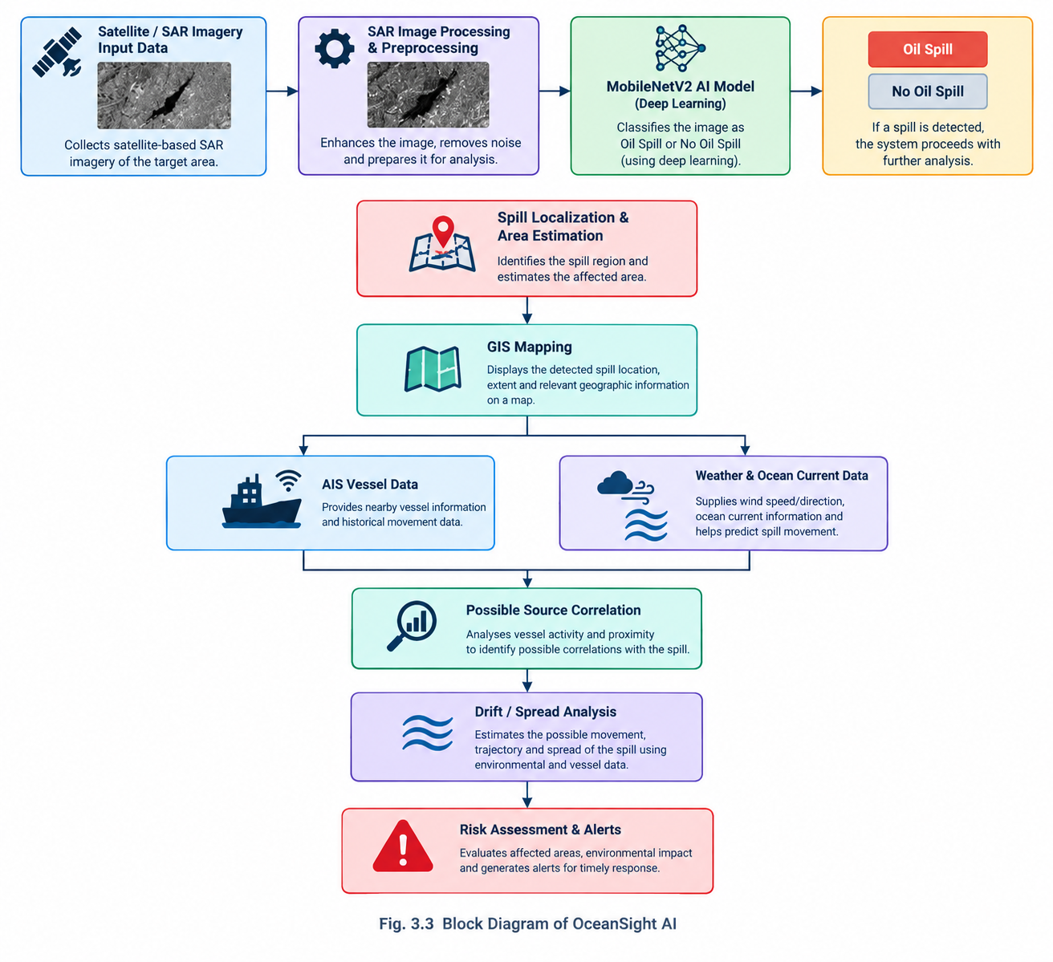

System Workflow

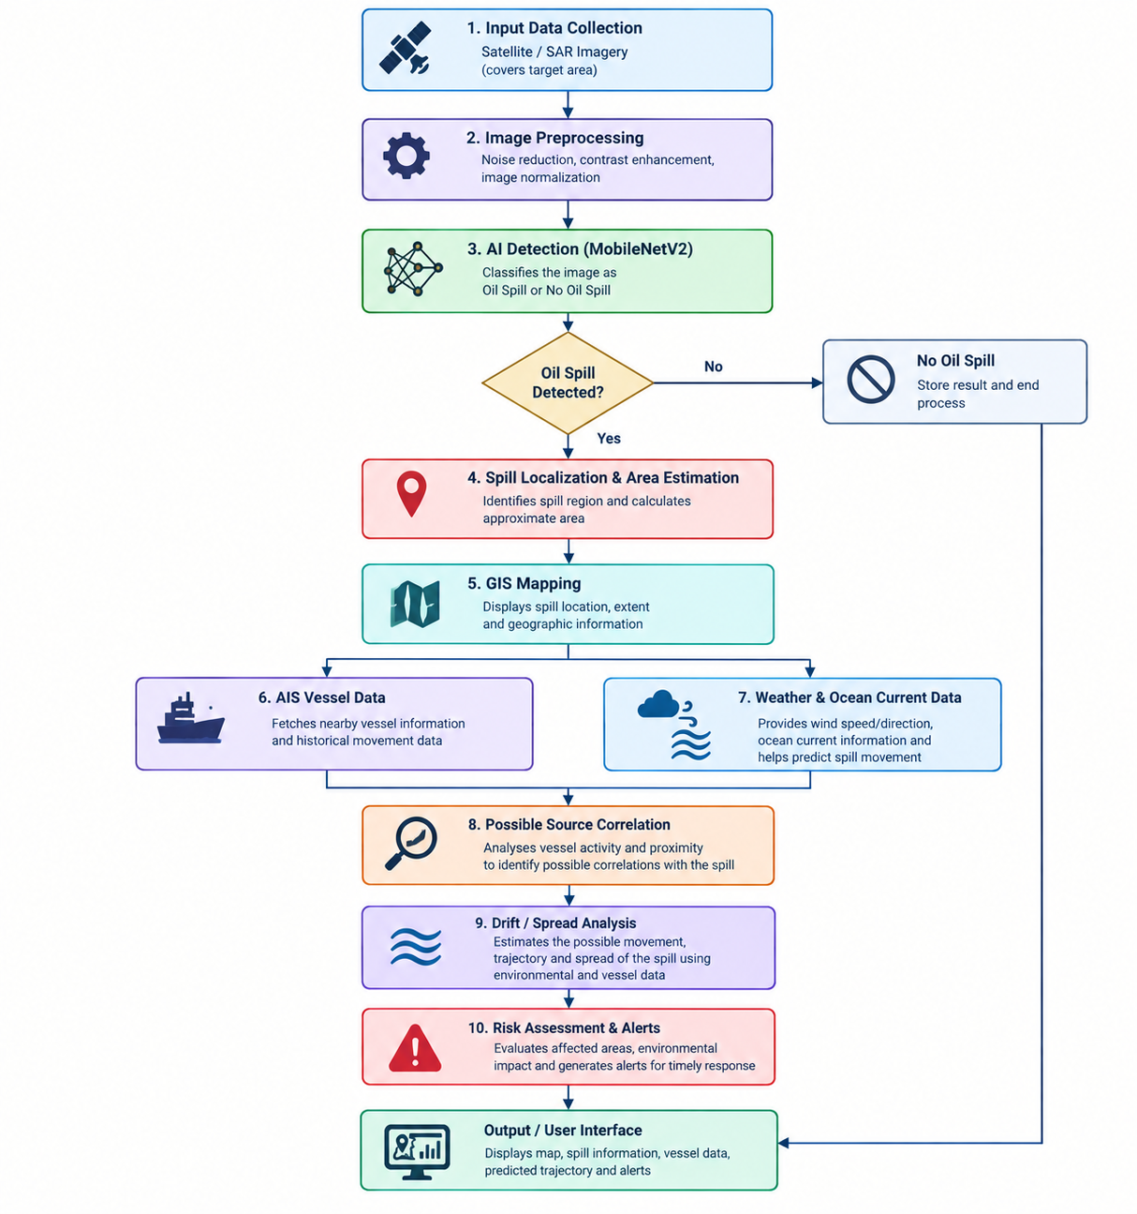
\

3.4. Software Packages & Libraries

The development of OceanSight AI requires several software packages, programming libraries, data services, and visualization components working together. The software environment supports the complete workflow, beginning with satellite image acquisition and image preprocessing, followed by artificial intelligence-based oil spill classification, geographic visualization, vessel analysis, and environmental-data processing. Python is used as the primary programming language for machine learning and backend processing, while web technologies are used to provide an interactive monitoring interface.
The major software components used or integrated within the system are summarized in Table 3.2.

3.4.1 Software Development Environment

Software / Library | Purpose in OceanSight AI
Python | Main programming language for machine learning, image processing, data handling, and backend processing
TensorFlow / Keras | Development, training, loading, and inference of the deep-learning model
MobileNetV2 | Lightweight convolutional neural network used for Oil Spill / No Oil Spill classification
OpenCV | Image processing and extraction of approximate candidate spill boundaries
NumPy | Numerical computation, array manipulation, and image-data processing
FastAPI | Backend API framework for handling analysis requests and connecting system components
HTML | Structure of the web-based monitoring interface
JavaScript | Client-side interaction, monitoring controls, map updates, and communication with the backend
These components are not used independently. They form a connected software pipeline in which satellite imagery is processed, passed to the trained AI model, analyzed further, and presented through the monitoring interface.

3.4.2 Python
Python is used as the primary programming language for OceanSight AI. Its extensive support for machine learning, image processing, numerical computation, and web development makes it suitable for implementing the different stages of the proposed system.
Python is used for:
- Loading and preprocessing satellite and image data.
- Running the trained MobileNetV2 model.
- Performing numerical operations on image data.
- Processing model predictions.
- Supporting image-based candidate boundary analysis.
- Communicating with external data services.
- Implementing backend processing and API functions.
- Preparing information for visualization on the monitoring dashboard.
The use of a common programming environment also allows the machine-learning and data-processing components to be connected without requiring separate software platforms for each stage.

3.4.3 TensorFlow and Keras

TensorFlow and Keras are used for the development and execution of the deep-learning model. Keras provides a high-level interface for constructing and working with neural-network models, while TensorFlow provides the underlying framework for model computation and inference.
Within OceanSight AI, the framework is used to:
- Load the MobileNetV2 architecture.
- Prepare image inputs for model inference.
- Train and fine-tune the classification model.
- Apply data augmentation during training.
- Use class weights to address the imbalance between the two classes.
- Generate prediction probabilities for new images.
- Save and reload the trained model for later use.
The trained model produces a probability associated with the oil-spill class. This probability is subsequently interpreted by the monitoring system to determine the classification result.

3.4.4 MobileNetV2
MobileNetV2 is the main deep-learning architecture used for image classification in OceanSight AI. It is used because the project requires a model capable of performing image classification while remaining relatively lightweight compared with larger convolutional neural networks.
The model is configured for the project's binary classification task:
Model Parameter | Configuration
Model | MobileNetV2
Task | Binary image classification
Class 0 | No Oil Spill
Class 1 | Oil Spill
Input Size | 224 × 224 × 3
Output | Oil-spill probability / classification
Training Support | Data augmentation and class weighting
The model receives a preprocessed satellite image and estimates the probability that the image contains an oil spill. This classification forms the AI-based detection stage of the OceanSight AI pipeline.

3.4.5 OpenCV

OpenCV (Open Source Computer Vision Library) is used for image-processing operations within the system. While MobileNetV2 provides the main classification result, OpenCV can be used to further process the image and identify an approximate candidate region corresponding to a detected spill.
Its role includes:
- Reading and manipulating image data.
- Converting and processing image representations.
- Performing image-based operations after classification.
- Supporting threshold-based candidate-region extraction.
- Generating approximate boundary information for visualization.
- Preparing image information for further analysis.
This distinction is important because the current MobileNetV2 model performs image-level classification, while the OpenCV stage provides additional image-processing support for representing a possible spill region.

3.4.6 NumPy
NumPy is used for numerical and array-based operations throughout the machine-learning and image-processing pipeline. Satellite and image data are represented as numerical arrays, making NumPy an important supporting library.
It is used for:
- Manipulating image arrays.
- Performing numerical calculations.
- Preparing model input arrays.
- Processing prediction values.
- Supporting image-processing operations.
- Handling numerical data generated during analysis.
NumPy therefore acts as a supporting computational layer between the image-processing and machine-learning components.

3.4.7 FastAPI
FastAPI is used as the backend framework for connecting the processing components with the OceanSight AI monitoring interface. It provides an API-based structure through which requests can be received from the user interface and corresponding analysis results can be returned.
The backend can support operations such as:
- Receiving analysis requests.
- Processing uploaded SAR imagery.
- Triggering AI-based classification.
- Returning model prediction results.
- Providing processed information to the monitoring dashboard.
- Connecting the interface with external data-processing functions.
The use of a backend API separates the user interface from the underlying analysis logic, making the system easier to organize and extend.

3.4.8 HTML and JavaScript
HTML and JavaScript are used to create the web-based monitoring interface of OceanSight AI.
HTML provides the basic structure of the dashboard, while JavaScript handles interactive functions and communication between the user interface and backend services.

The interface supports functions such as:
- Selecting monitoring modes.
- Initiating analysis operations.
- Displaying SAR analysis results.
- Presenting oil-spill detection information.
- Updating geographic information on the map.
- Displaying system status and analysis outputs.
- Communicating with backend services.
The web interface provides a common platform through which the different analytical outputs can be presented to the user.

3.4.9 External Data Sources and Services

OceanSight AI also depends on external data sources for satellite, vessel, geographic, and environmental information. These sources extend the system beyond image classification and allow the detected spill to be analyzed in a wider spatial and environmental context.

Data Source / Service | Information Used | Purpose
Copernicus Data Space | Sentinel satellite data | Acquisition of satellite imagery for marine monitoring
Sentinel-1 GRD | SAR imagery | Oil-spill detection and SAR-based analysis
AIS Data Service | Vessel position, identity, speed, heading, timestamp | Nearby-vessel and movement-history analysis
Environmental Data Service | Wind and related environmental information | Analysis of environmental conditions affecting spill movement
GIS / Map Data | Coastlines, geographic regions, marine features | Spatial visualization and impact analysis
The role of these external sources is summarized below.

3.4.10 Copernicus Data Space and Sentinel-1
The Copernicus Data Space is used as a source for satellite datasets, including Sentinel-1 SAR imagery. Sentinel-1 is particularly relevant to the project because SAR observations can support marine monitoring under conditions where conventional optical imagery may be affected by cloud cover or lighting conditions.
The satellite-data stage provides the imagery required for the detection pipeline:
Satellite Data → SAR Image → Preprocessing → AI Classification → Spill Analysis
The acquired imagery can subsequently be passed through the OceanSight AI processing pipeline for classification and visualization.

3.4.11 AIS Data
The Automatic Identification System (AIS) provides vessel-related information that can be used after a potential oil spill has been identified. Relevant information can include:
- Vessel position.
- Vessel identity.
- Speed.
- Heading.
- Timestamp.
- Historical movement information.

AIS information is used to identify vessels operating near a detected spill and to examine their movement history. This provides supporting information for possible source correlation.

It is important to distinguish correlation from attribution. The presence of a vessel near a detected spill does not by itself establish that the vessel caused the spill. AIS information is therefore treated as supporting evidence for further analysis.

3.4.12 Environmental Data
Environmental information is incorporated to understand conditions that may influence the movement of an oil spill. Important parameters include:
- Wind speed.
- Wind direction.
- Ocean-current information.
- Other available environmental conditions.
These parameters can be combined with the detected spill location to estimate the possible direction of movement and potential areas of impact.

3.4.13 Role of Environmental Parameters

Parameter | Role in Analysis
Wind Speed | Indicates the strength of wind conditions influencing surface movement
Wind Direction | Provides an indication of the direction of wind-driven movement
Ocean Currents | Supports estimation of water-driven spill movement
Spill Location | Provides the starting point for movement analysis
Time | Allows movement to be considered over different prediction periods

3.4.14 Role of Software Components in the pipeline
The major software components work together as a sequence rather than as isolated tools.

3.4.15 Software Component Input–Output Relationship

Component | Input | Main Output
Copernicus Data Space | Geographic search region | Sentinel satellite data
SAR Processing | Sentinel-1 imagery | Processed SAR image
MobileNetV2 | 224 × 224 × 3 image | Oil-spill probability
OpenCV | Processed image | Candidate spill-region information
AIS Service | Spill coordinates / search region | Nearby vessel information
Environmental Service | Geographic coordinates / time | Wind and environmental information
FastAPI | User/system requests | Processed analysis results
JavaScript Dashboard | Backend outputs | Interactive monitoring display
GIS / Map Layer | Geographic and analysis data | Spatial visualization
The overall relationship between these components can be represented as:
Satellite Data
↓
SAR Image Processing
↓
MobileNetV2 Classification
↓
Oil Spill / No Oil Spill
↓
Spill Location and Candidate Region
↓
GIS Mapping
↓
AIS Vessel Analysis + Environmental Analysis
↓
Drift and Risk Assessment
↓
OceanSight AI Monitoring Dashboard
Thus, the software environment provides the foundation for integrating AI-based detection, satellite imagery, image processing, GIS visualization, AIS vessel information, and environmental analysis into a single marine monitoring workflow.

OceanSight AI uses software components for machine learning, image processing, backend services, data retrieval, and visualization.
Google Colab Training Environment

4. ML TRAINING PLATFORM
The machine learning development and training process for OceanSight AI was carried out using Google Colab, a cloud-based development environment that supports Python programming and machine learning workflows. Google Colab provides an interactive notebook-based environment in which the dataset can be prepared, the classification model can be trained, predictions can be tested, and the trained model can be saved for integration with the main application.
Using a cloud-based training environment was useful for the project because the machine learning workflow required repeated experimentation with image data, model configuration, augmentation, and class balancing. The notebook-based approach also allowed the different stages of the experiment to be organized and executed sequentially.

4.1 Google Colab Training Environment

Component | Role in OceanSight AI
Google Colab | Cloud-based platform used for ML development and training
Python | Programming environment used inside the notebook
Jupyter Notebook Environment | Organizes code, outputs, and experiments into sequential cells
TensorFlow / Keras | Supports model development and training
Dataset Storage / Loading | Provides access to the image dataset during training
Model Output | Produces the trained classification model for later inference

Training Environment
Google Colab provides an interactive notebook environment where machine learning experiments can be developed step by step. Instead of maintaining the complete training environment locally, the project uses the cloud-based Colab environment to execute the required Python and machine-learning operations.
The training environment was used for:
- Loading the image dataset.
- Organizing images according to their classes.
- Preparing images for model input.
- Applying training-time augmentation.
- Handling class imbalance using class weights.
- Training the classification model.
- Testing the trained model with sample images.
- Examining prediction outputs.
- Saving the trained model for subsequent use.

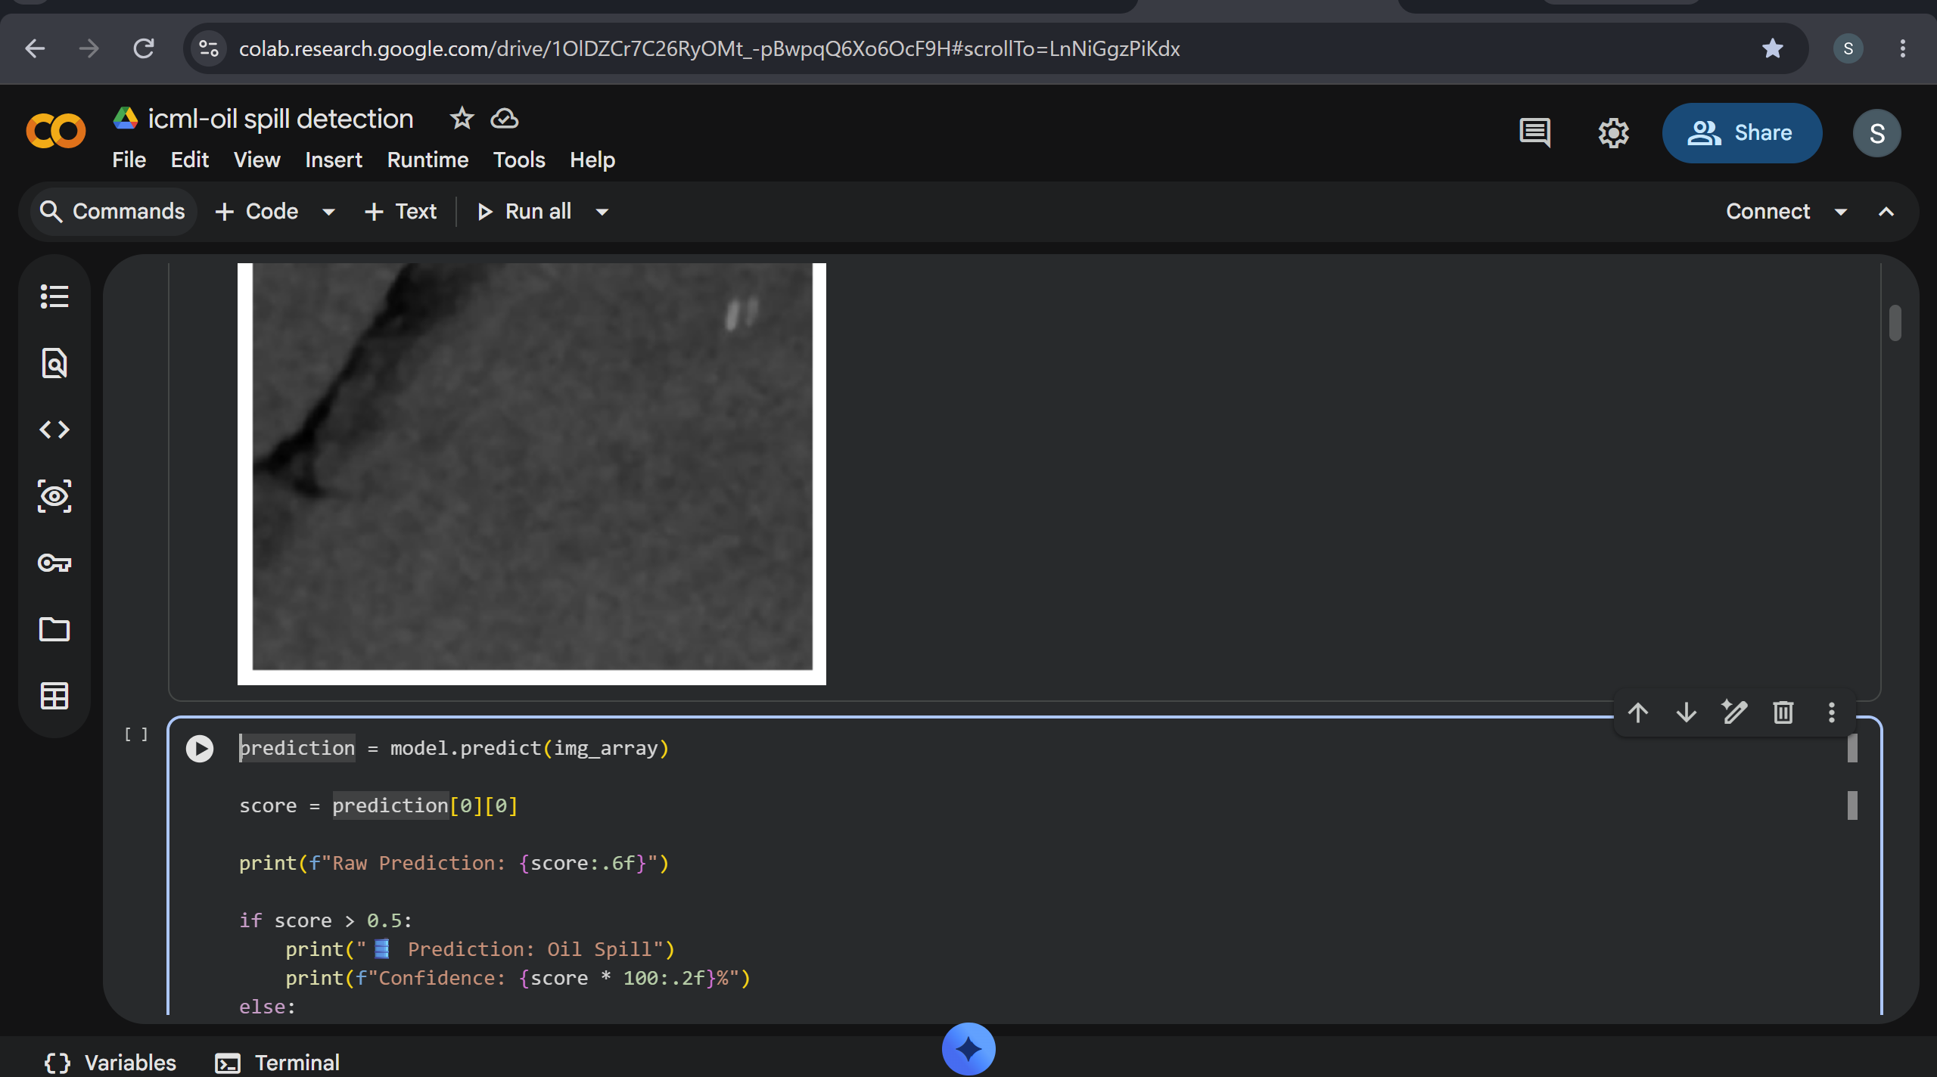

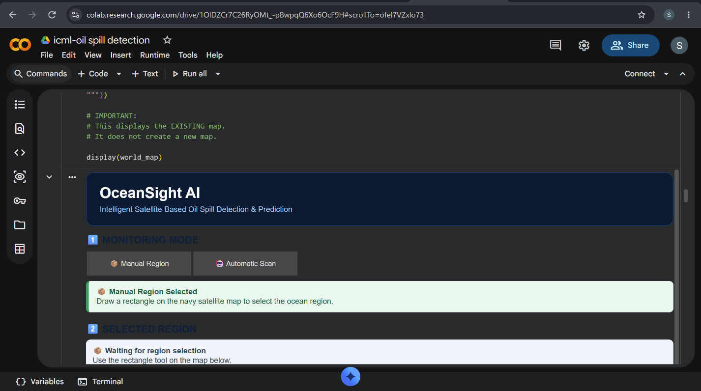

4.2 Training Workflow in Google Colab

Stage | Activity
1 | Set up the Colab notebook environment
2 | Load the project dataset
3 | Organize the image classes
4 | Prepare the image data
5 | Configure the training process
6 | Apply augmentation and class weighting
7 | Train the model
8 | Evaluate and inspect predictions
9 | Save the trained model
10 | Use the saved model for inference

4.2.1 Notebook-Based Development
The notebook structure of Google Colab allows the training process to be divided into individual stages. Each stage can be executed and inspected separately, making it easier to identify problems during dataset preparation or model development.
The notebook-based workflow also provides a convenient way to record:
- Dataset loading operations.
- Preprocessing steps.
- Training configurations.
- Model outputs.
- Prediction results.
- Experimental observations.
This organization is particularly useful during model development because changes to the training process can be tested without rebuilding the entire application.

4.2.2 Model Training Using Google Colab
The trained classification model was developed and trained within the Colab environment. The training process uses the prepared image dataset and the configured machine-learning pipeline described in the following sections.

The general relationship between the training platform and the model-development process is:
Google Colab
↓
Dataset Preparation
↓
Training Configuration
↓
Model Training
↓
Prediction Testing
↓
Trained Model
↓
OceanSight AI Inference
The trained model can subsequently be incorporated into the OceanSight AI analysis pipeline, where new images can be processed and classified.

4.2.3 Advantages of the Selected Training Platform
Google Colab was suitable for the project because it provides a ready-to-use environment for machine-learning experimentation without requiring the complete software stack to be configured manually on the local system.

4.3 Benefits of Google Colab for the Project

Feature | Relevance to OceanSight AI
Cloud-Based Execution | Allows model development without depending entirely on local computing resources
Notebook Interface | Keeps code, outputs, and experiments organized
Python Support | Provides the required programming environment
ML Framework Support | Supports the frameworks required for deep-learning development
Interactive Execution | Allows individual training stages to be tested and modified
Experimentation | Makes it convenient to repeat training with different configurations
Model Export | Allows the trained model to be saved for later inference

4.4 Training Platform Summary
The machine-learning component of OceanSight AI was therefore developed using Google Colab as the primary training platform. The platform was used to organize the dataset, execute the training workflow, experiment with the classification model, inspect predictions, and obtain the trained model required for the detection stage.
The training platform forms the development layer between the project dataset and the final AI-based detection system, while the detailed dataset preparation and model architecture are discussed separately in the following sections.

5. Data Collection
The machine learning component of OceanSight AI requires a collection of labelled images representing marine conditions with and without visible oil-spill patterns. The dataset used for the classification task was organized into two classes: No Oil Spill and Oil Spill. These labelled images provide the examples required for supervised learning.
The dataset contains a total of 5,548 images. The distribution between the two classes is not equal, with the No Oil Spill class containing a larger number of images. This imbalance was considered during the model-development process and was subsequently addressed during training.

5.1Dataset Composition

Class | Description | Number of Images
Class 0 | No Oil Spill | 3,695
Class 1 | Oil Spill | 1,843
Total | — | 5,548
The dataset provides the primary image input for the AI-based classification stage. Each image is associated with one of the two predefined labels, allowing the model to learn the visual characteristics associated with the presence or absence of an oil spill.

5.2 Class Distribution
The difference in the number of images between the two classes is an important characteristic of the dataset.

5.2.1 Class Distribution Summary

Class | Images | Approximate Share
No Oil Spill | 3,695 | 66.6%
Oil Spill | 1,843 | 33.2%
Total | 5,548 | 100%
The dataset therefore contains approximately twice as many No Oil Spill examples as Oil Spill examples. Rather than treating this difference as an error in the dataset, the imbalance was considered as part of the training configuration.

5.3 Role of the Dataset in OceanSight AI
The collected image dataset is used specifically for developing the AI-based detection component. It provides the visual examples from which the classification model learns patterns associated with oil-spill and non-oil-spill conditions.
The role of the dataset can be summarized as follows:
- Provides labelled examples for supervised learning.
- Represents both oil-spill and non-oil-spill conditions.
- Forms the primary image input for model development.
- Allows the model to learn distinguishing visual patterns.
- Provides images for testing model predictions.
- Supports the development of the automated detection stage.
The machine-learning dataset should be distinguished from the additional operational data used by the wider OceanSight AI system. AIS, GIS, and environmental information are used to extend the analysis after a potential spill is identified; they are not treated as additional classes in the image-classification dataset.

5.4 External Data Used by the Monitoring System
Beyond the image dataset, OceanSight AI is designed to work with several categories of external information during marine monitoring.

5.5 Operational Data Categories

Data Category | Information | Role
Satellite / SAR Data | Sentinel-1 imagery | Marine observation and spill analysis
AIS Data | Vessel position and movement information | Possible source correlation
GIS Data | Geographic and marine features | Spatial representation
Environmental Data | Wind and ocean conditions | Movement and drift analysis

These data categories serve different purposes within the overall system. The labelled image dataset supports machine-learning development, whereas operational data provides additional context for analysing detected events.

6. Data Preprocessing and Augmentation
Before images are provided to the classification model, they are prepared in a consistent format. Data preprocessing ensures that the images used during model development have the dimensions and structure expected by the neural network.
The preprocessing stage also includes controlled image augmentation. Since the available images do not represent every possible orientation, scale, or visual appearance that may occur in practice, augmentation is used to introduce additional variation during training.

6.1 Image Preprocessing
The images are prepared using a fixed input configuration of 224 × 224 pixels with three colour channels. Standardizing the image dimensions allows different input images to be processed consistently by the classification model.

6.1.1 Image Preprocessing Configuration

Parameter | Configuration
Image Width | 224 pixels
Image Height | 224 pixels
Image Channels | 3
Final Input Shape | 224 × 224 × 3
Processing Purpose | Standardized model input
The preprocessing stage can therefore be represented as:
Original Image → Resize → Standardized Image → Model Input
Maintaining a consistent input format ensures that the image data can be passed through the same processing pipeline during both model development and subsequent inference.

6.2 Data Augmentation
Data augmentation is applied to introduce controlled variations into the training images. The purpose is not to change the class of an image, but to expose the model to different visual representations of the same underlying class.
The augmentation operations used in the project are shown below.

6.2.1 Data Augmentation Operations

Augmentation | Purpose
Random Flip | Introduces variation in image orientation
Random Rotation | Provides variation in the orientation of visual patterns
Random Zoom | Exposes the model to changes in image scale
Random Contrast | Introduces variation in image contrast and appearance
These transformations allow the training process to use a wider range of visual patterns without requiring a completely new image to be collected for every possible variation.

6.2.3 Importance of Augmentation
Marine imagery can vary considerably in appearance because of differences in scene composition, image orientation, scale, and contrast. A model that sees only highly similar training examples may become overly dependent on specific visual characteristics of those examples.
Augmentation helps address this issue by introducing controlled variation during training.
Its main purposes are:
- Increase variation in training samples.
- Reduce excessive dependence on the original appearance of images.
- Improve exposure to different orientations.
- Introduce scale variation.
- Introduce differences in visual contrast.
- Support better generalization to varied input images.

6.3 Preprocessing and Augmentation Pipeline

Stage | Operation | Result
1 | Load labelled image | Original image
2 | Resize | 224 × 224 image
3 | Prepare three-channel input | 224 × 224 × 3
4 | Apply random flip | Orientation variation
5 | Apply random rotation | Rotation variation
6 | Apply random zoom | Scale variation
7 | Apply random contrast | Appearance variation
8 | Provide processed sample for training | Model-ready input

6.4 Relationship Between Preprocessing and Training
The preprocessing stage provides a consistent input format, while augmentation increases the variety of training examples. Together, they prepare the dataset for the subsequent model-training stage.

The complete data-preparation sequence is:
Labelled Dataset
↓
Image Loading
↓
Image Resizing
↓
Input Standardization
↓
Training-Time Augmentation
↓
Prepared Training Data
↓
ML Model Training
The preprocessing and augmentation stages therefore act as the connection between the collected dataset and the machine-learning model.

7. ML MODEL
The machine learning component of OceanSight AI is responsible for identifying whether an input marine image represents an Oil Spill or No Oil Spill condition. The developed system uses a MobileNetV2-based image classification model as the primary AI model. The model was trained using the prepared labelled dataset and subsequently used to generate predictions for new images.
The machine learning stage is intentionally separated from the later GIS, AIS, environmental, and drift-analysis stages. Its primary responsibility is to provide an initial AI-based indication of whether an oil-spill pattern is present in the input image.

7.1 MobileNetV2
MobileNetV2 is used as the main convolutional neural network architecture for image classification in OceanSight AI. The architecture is suitable for applications where useful image-recognition capability is required without relying on an excessively large neural network.
For this project, MobileNetV2 is configured as a binary classifier. The model learns from labelled examples belonging to two categories and produces a prediction corresponding to the presence or absence of an oil spill.

7.1.1 MobileNetV2 Model Configuration

Parameter | Configuration
Model Architecture | MobileNetV2
Application | Marine oil-spill image classification
Classification Type | Binary classification
Class 0 | No Oil Spill
Class 1 | Oil Spill
Input Format | 224 × 224 × 3
Output | Oil-spill prediction probability
Framework | TensorFlow / Keras
The model receives a standardized image and processes it through its convolutional feature-extraction layers. These layers learn visual characteristics from the training examples and pass the extracted features to the classification stage.

7.1.2 Model Architecture
The general architecture used for OceanSight AI can be represented as:
Input Image
↓
MobileNetV2 Feature Extraction
↓
Learned Visual Features
↓
Classification Layer
↓
Oil-Spill Probability
↓
Oil Spill / No Oil Spill
The feature-extraction stage enables the network to identify visual patterns within the input image, while the final classification stage converts these learned features into a binary prediction.

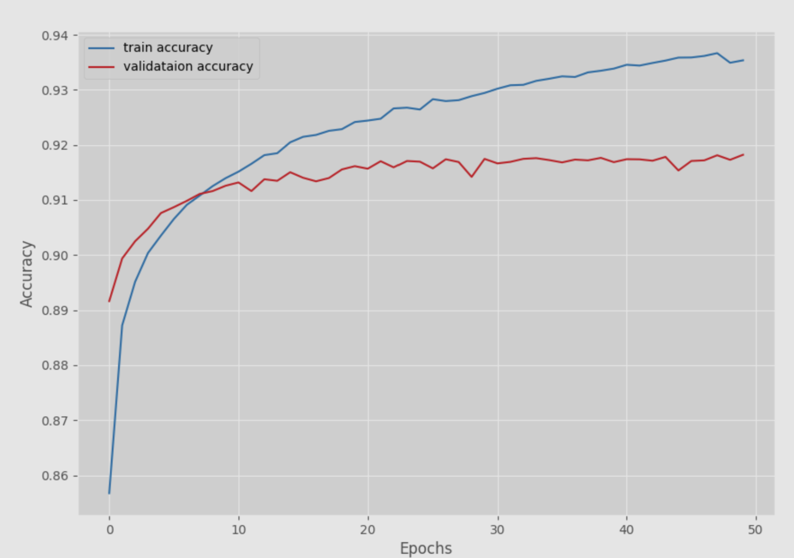

Training
The dataset contains SAR images divided into oil-spill and non-oil-spill classes. During training, the MobileNetV2 model learns patterns and features from the training images, such as the texture, shape, and intensity characteristics associated with oil spills. The images are resized to 224 × 224 pixels, and the model's weights are updated using backpropagation to minimize the classification loss. Class weights were also used to handle the imbalance between the two classes.

Validation
The validation dataset contains images that are not used to update the model's weights. It is used during training to check how well the model performs on unseen images and whether it is overfitting to the training data. Metrics such as validation accuracy and validation loss are monitored after each epoch. A good validation performance indicates that the model has learned general features that can be applied to new SAR images rather than simply memorizing the training samples.

7.1.3 Functional Stages of the Model

Stage | Function
Input | Receives the prepared marine image
Feature Extraction | Identifies useful visual characteristics
Deep Feature Representation | Converts image information into learned numerical features
Classification | Uses learned features to distinguish the two classes
Output | Produces the prediction probability
The MobileNetV2 model therefore acts as the main decision-making component of the AI detection stage.

7.1.4 Model Training
The MobileNetV2 model was trained using the labelled image dataset prepared for OceanSight AI. During training, the network learns the visual characteristics associated with the two target classes.
The training process follows a supervised learning approach in which each training image is associated with a known class label. The model compares its prediction with the corresponding label and updates its internal parameters during the learning process.

7.1.5 Model Training Stages
Stage |  | Activity
1 |  | Load prepared training images
2 |  | Associate images with class labels
3 |  | Pass images through the MobileNetV2 network
4 |  | Generate class predictions
5 |  | Compare predictions with known labels
6 |  | Calculate training error
7 |  | Update model parameters
8 |  | Repeat the process across training samples
9 |  | Evaluate the trained model
10 | Save the trained model for inference
The training process allows the network to gradually learn image characteristics that help distinguish oil-spill patterns from non-oil-spill conditions.

7.2 Training Behaviour
During training, the model is exposed to different examples from the two classes. The use of the prepared training data and augmentation allows the network to encounter variations in image appearance rather than repeatedly seeing identical input patterns.
The model achieved approximately 93% training accuracy during development. This value represents the model's performance on the training process and should not be interpreted as a complete measure of real-world performance. Further validation and testing using independent data are important when assessing generalization.

7.2.1 Training Result

Metric | Observed Result
Training Accuracy | Approximately 93%
Training Task | Binary classification
Target Classes | No Oil Spill / Oil Spill
The training result demonstrates that the model was able to learn a meaningful distinction between the two classes within the available training data.

7.3 Class Weights
The dataset contains a larger number of No Oil Spill images than Oil Spill images. To account for this difference during training, class weights were incorporated into the learning process.
Class weighting increases the contribution of examples belonging to the less represented class. This helps prevent the model from becoming overly influenced by the larger class simply because it contains more training examples.

7.4 INFERENCE
After training, the saved MobileNetV2 model is used during the inference stage to analyze new images. Inference refers to using the trained model to generate predictions without further updating the model parameters.
When a new image is provided to OceanSight AI, it follows the same required input preparation before being passed to the trained model. MobileNetV2 then processes the image and produces a probability associated with the Oil Spill class.

7.4.1 Inference Process
Stage | Operation
1 | Receive a new input image
2 | Prepare the image using the required input format
3 | Pass the image to the trained MobileNetV2 model
4 | Calculate the model output
5 | Obtain the Oil Spill probability
6 | Interpret the prediction
7 | Display the classification result
8 | Forward the result for further system analysis
The prediction output can be expressed conceptually as:
Input Image → Trained Model → Probability → Classification
The model output provides an AI-based indication rather than a complete environmental assessment. A positive classification therefore acts as the starting point for subsequent analysis using SAR information, geographic location, vessel information, and environmental conditions.

7.5 Prediction Interpretation
The model's probability output can be used to understand how strongly the model associates an input image with the Oil Spill class.

7.5.1 Prediction Interpretation table

Model Output | Interpretation
Higher Oil Spill probability | Model has stronger evidence for the Oil Spill class
Lower Oil Spill probability | Model has weaker evidence for the Oil Spill class
Classification result | Final binary interpretation used by the application
The prediction confidence should be interpreted together with the image and other available information. A high model probability does not independently establish the existence, source, severity, or environmental impact of an actual marine oil-spill event. 4.8 Boundary Analysis

7.6 Boundary Analysis Stages

The classification model determines whether an input image is associated with the Oil Spill class, but the classification output itself does not provide a detailed pixel-level segmentation of the spill. Therefore, image-processing-based boundary analysis is used as an additional step to identify an approximate candidate region within an image.
This stage uses image-processing operations to highlight regions that may correspond to the detected spill pattern. The resulting boundary information is intended for visualization and approximate spatial representation rather than precise segmentation.

7.6.1 Boundary Analysis Stages table

Stage | Operation | Purpose
1 | Input image | Provides the image for region analysis
2 | Image conversion | Prepares the image for processing
3 | Thresholding | Separates candidate regions from surrounding pixels
4 | Morphological processing | Reduces small unwanted regions and improves candidate areas
5 | Contour detection | Identifies boundaries of candidate regions
6 | Region filtering | Removes unsuitable small regions
7 | Boundary generation | Produces an approximate candidate boundary
8 | Visualization | Displays the candidate region for analysis
The boundary-analysis process can be represented as:
Input Image
↓
Image Processing
↓
Thresholding
↓
Morphological Operations
↓
Contour Detection
↓
Candidate Region
↓
Approximate Boundary

7.7 Candidate Region Analysis
The purpose of candidate boundary analysis is to provide additional spatial information after the AI classification stage. If the model identifies an image as potentially containing an oil spill, image-processing techniques can be used to identify a region within the image that may correspond to the detected pattern.
The resulting candidate region can provide:
- Approximate boundary information.
- Visual indication of the suspected region.
- Support for map-based representation.
- Additional information for subsequent analysis.
- A more interpretable output than a classification label alone.

7.8 AI Detection and Boundary Analysis

Component | Main Function | Output
MobileNetV2 | Determines image-level class | Oil Spill / No Oil Spill probability
Image Processing | Examines potential regions | Candidate spill region
Contour Analysis | Identifies region boundaries | Approximate boundary
GIS Layer | Represents geographic information | Spatial visualization
It is important to note that the boundary generated by this stage is an approximate candidate boundary. It should not be interpreted as a scientifically validated spill perimeter or as a pixel-perfect segmentation result.

7.8.1 Role of Boundary Analysis in OceanSight AI
Boundary analysis extends the output of the classification model by providing an approximate visual representation of where a potential spill pattern occurs within the analyzed image.
The combined process is:
AI Classification
→ Potential Oil Spill Identified
→ Candidate Region Analysis
→ Approximate Boundary
→ GIS Representation
→ Further AIS and Environmental Analysis
This allows the machine-learning stage to provide both a classification result and supporting spatial information for the broader OceanSight AI monitoring workflow.

7.9 ML Model Summary
The complete machine-learning process can therefore be summarized as:

7.9.1 Model Summary

Component | Function
MobileNetV2 | Image-level oil-spill classification
Training | Learns visual patterns from labelled examples
Class Weights | Compensates for unequal class representation
Inference | Generates predictions for new images
Boundary Analysis | Produces approximate candidate-region information

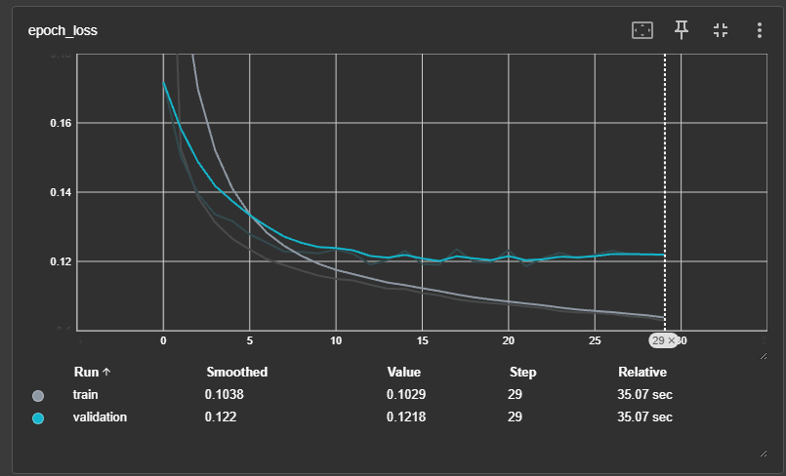

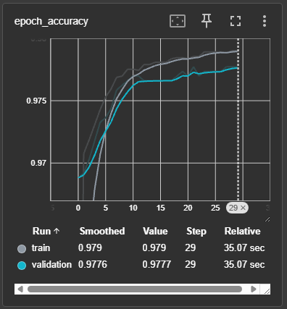

8. SYSTEM OPERATION FLOW

The OceanSight AI system is designed to support both manual and automatic marine monitoring. The operation begins with the selection or retrieval of satellite imagery and continues through oil-spill analysis, geographic representation, vessel correlation, environmental analysis, and drift assessment.
The system provides two operating modes. Manual Mode allows the user to provide or select imagery for analysis, while Automatic Mode is intended to retrieve suitable Sentinel-1 data for a selected monitoring region. After a potential spill is identified, the system can combine geographic, vessel, and environmental information to provide a broader interpretation of the event.

8.1 Manual Mode

Manual Mode provides a direct way for the user to analyze a selected image. This mode is useful when a particular SAR image is already available or when the user wants to examine a specific region or event.

The general manual operation is:
Select / Upload SAR Image
↓
Image Analysis
↓
AI-Based Classification
↓
Spill Result
↓
Candidate Region Analysis
↓
GIS Visualization

8.1.1 Manual Mode Operation

Stage | Operation | Result
1 | Select monitoring option | Manual analysis initiated
2 | Provide SAR image | Image available for processing
3 | Process image | Model-ready image
4 | Perform AI analysis | Classification result
5 | Analyze candidate region | Approximate spill region
6 | Display result | Visual analysis output
7 | Continue spatial analysis | GIS-based representation
Manual Mode provides greater control over the input being analyzed and is particularly useful during testing, demonstration, and examination of specific SAR scenes.

8.2 Automatic Mode
Automatic Mode is designed to reduce the need for manual image selection by allowing the system to retrieve satellite data for a specified monitoring region.
The automatic workflow begins with a selected geographic region and proceeds toward satellite-data retrieval and subsequent analysis.

8.2.1 Automatic Mode Operation

Stage | Operation
1 | Select monitoring region
2 | Initiate automatic scan
3 | Search for available Sentinel-1 data
4 | Retrieve suitable satellite imagery
5 | Process retrieved imagery
6 | Perform oil-spill analysis
7 | Display detected information
8 | Continue GIS, AIS, and environmental analysis
Automatic Mode is intended to support repeated monitoring and reduce dependence on manually uploaded images.

8.3 Sentinel-1 Data Retrieval
Sentinel-1 SAR imagery forms an important source of satellite information for the monitoring workflow. In Automatic Mode, the system can search for satellite observations corresponding to a selected geographic area.
The retrieval process can be represented as:
Monitoring Region
↓
Satellite Data Search
↓
Sentinel-1 Scene Selection
↓
SAR Data Retrieval
↓
Image Processing
↓
Oil-Spill Analysis

8.3.1 Sentinel-1 Retrieval Process

Input / Stage | Information
Monitoring Region | Geographic area selected for observation
Satellite Search | Searches available Sentinel-1 observations
Scene Selection | Identifies a suitable SAR scene
Data Retrieval | Obtains the selected satellite data
Processing | Prepares the imagery for analysis
AI Analysis | Examines the image for potential oil-spill patterns

The satellite retrieval stage allows the system to move toward an automated monitoring workflow rather than relying entirely on previously downloaded imagery.

8.4 GIS-Based Analysis
After a potential oil spill has been identified, geographic information is used to represent the event spatially. Geographic Information System (GIS) functionality allows the detected location and related information to be displayed on a map.
The GIS layer can provide a common spatial reference for different information sources.

8.4.1 GIS Information Layers

Layer | Information Represented
Spill Location | Geographic position of the detected event
Candidate Boundary | Approximate detected region
Satellite / SAR Information | Source imagery and observation area
Coastline | Nearby coastal regions
Vessel Information | AIS-based vessel positions
Vessel Tracks | Historical movement information
Sensitive Regions | Potentially affected marine or coastal areas
Predicted Movement | Estimated spill-drift direction
GIS therefore acts as the spatial integration layer of OceanSight AI, allowing information from different sources to be examined in relation to the detected spill.

8.5 AIS Vessel Analysis

Once a potential spill location is available, Automatic Identification System (AIS) information can be examined to identify vessels operating in or around the affected region.
AIS data may provide information such as vessel identity, position, speed, heading, and timestamp. Historical vessel movement can also be examined to determine whether a vessel's track shows a possible spatial or temporal relationship with the detected event.

8.5.1 AIS Parameters Used for Analysis

Parameter | Purpose
Vessel Identity | Identifies the vessel associated with the AIS record
Position | Determines the vessel's geographic location
Speed | Provides vessel movement information
Heading | Indicates the direction of travel
Timestamp | Establishes when the vessel was at a particular location
Historical Track | Supports examination of previous vessel movement
The AIS analysis is intended for possible source correlation, rather than definitive attribution. A vessel being located near a detected spill does not by itself establish that the vessel caused the spill.
The general process is:
Detected Spill Location
↓
Search Nearby AIS Records
↓
Identify Relevant Vessels
↓
Examine Position and Movement
↓
Compare Spatial and Temporal Information
↓
Possible Source Correlation

8.6 Environmental Data Analysis
Environmental conditions are considered because the movement of an oil spill can be influenced by conditions in the surrounding marine environment. OceanSight AI incorporates available environmental information to provide additional context for analysing the detected event.
The main parameters considered include wind speed, wind direction, and ocean-current information.

8.6.1 Environmental Parameters

Parameter | Relevance
Wind Speed | Indicates the strength of wind conditions
Wind Direction | Provides the direction of wind influence
Ocean Currents | Indicates water movement affecting the spill
Spill Location | Starting point for movement analysis
Observation Time | Establishes the time associated with environmental conditions
Environmental information is combined with the detected spill location to support the subsequent drift-analysis stage.

8.7 Drift Analysis
The drift-analysis stage examines how a potential oil spill may move from its detected location under the influence of environmental conditions. The analysis considers the current spill position together with available wind and ocean-current information.
The conceptual process is:

Current Spill Location
+
Wind Conditions
+
Ocean Currents
↓
Drift Estimation
↓
Possible Future Spill Position
↓
GIS Visualization

8.7.1 Drift Analysis Inputs and Outputs

Category | Information
Initial Condition | Detected spill location
Wind Input | Wind speed and direction
Ocean Input | Ocean-current information
Time | Prediction period
Processing | Drift estimation
Output | Possible movement direction and future position
Visualization | Map-based representation
The system can use different future time periods to examine potential movement over time. A longer prediction period may result in a larger potential affected region, depending on the environmental conditions.

8.8 Spatiotemporal Interpretation
Drift analysis adds a time dimension to the spatial information obtained from the detection stage. Instead of considering only where a spill was detected, the system can examine how its possible location may change over time.

8.8.1 Spatiotemporal Analysis

Time Stage | Information Considered
Initial | Detected spill location
Short-Term | Possible movement under current conditions
Intermediate | Expanded potential movement region
Longer-Term | Potentially affected downstream regions
The drift output should be interpreted as an estimate of possible movement, rather than an exact prediction of the future spill boundary. Actual movement can depend on environmental conditions and the accuracy and resolution of the available data.

8.9 Integrated System Operation
The different operating stages are connected to form the overall OceanSight AI monitoring workflow.

8.9.1 Complete System Operation Flow

Stage | System Function
1 | Select Manual or Automatic Mode
2 | Provide or retrieve SAR imagery
3 | Analyze the satellite image
4 | Identify potential oil-spill condition
5 | Determine approximate candidate region
6 | Represent the event using GIS
7 | Examine nearby AIS vessel information
8 | Analyze environmental conditions
9 | Estimate possible spill movement
10 | Present combined information through the monitoring system
The complete workflow can therefore be summarized as:
Manual / Automatic Mode
↓
Sentinel-1 SAR Data
↓
Oil-Spill Detection
↓
Candidate Region
↓
GIS Mapping
↓
AIS Vessel Analysis
↓
Environmental Analysis
↓
Drift Estimation
↓
Spatiotemporal Risk Interpretation
This operation flow allows OceanSight AI to move beyond simple image classification and organize multiple sources of information around a potential marine oil-spill event. The resulting outputs provide a foundation for the assumptions, limitations, and results discussed in the following chapters.

9. ASSUMPTIONS
The OceanSight AI system is developed based on several practical assumptions regarding the availability, quality, and suitability of the data used by the monitoring workflow. These assumptions define the conditions under which the proposed system is expected to operate.

9.1 Data Assumptions
- The labelled image dataset is assumed to contain sufficiently representative Oil Spill and No Oil Spill samples for model training.
- Input images are assumed to be available in a suitable format and resolution for processing.
- Operational satellite, AIS, GIS, and environmental data are assumed to be available when required for monitoring and analysis.

9.2 Satellite and SAR Assumptions
- Sentinel-1 SAR imagery is assumed to provide sufficient visibility of the marine surface for identifying potential oil-spill patterns.
- SAR images are assumed to contain adequate spatial information for subsequent localization and GIS-based analysis.
- Detected dark regions in SAR imagery are treated as candidate oil-spill regions, since similar patterns may also occur due to other surface conditions.

9.3 AIS Assumptions
- AIS data is assumed to contain sufficiently accurate vessel positions, timestamps, speed, and heading information.
- Vessel locations occurring near a detected spill may be considered for possible source correlation.
- AIS proximity alone is not assumed to prove that a particular vessel caused the spill.

9.4 Environmental and Drift Assumptions
- Wind and ocean-current information is assumed to be available for the selected monitoring region.
- Spill movement is assumed to be influenced significantly by surface wind and ocean-current conditions.
- Drift analysis provides an estimated movement pattern rather than an exact prediction of the physical spread of the spill.

9.5 System Operation Assumptions
- The monitoring system is assumed to have sufficient network connectivity when retrieving external satellite, AIS, GIS, and environmental data.
- The different data sources are assumed to use compatible geographic and temporal information for integrated analysis.
- Results generated by the system are considered decision-support information and may require further verification by environmental or maritime authorities.

9.6 Summary of Assumptions

Category | Main Assumption
Dataset | Training images adequately represent the two classification classes
SAR Data | Satellite imagery contains usable marine surface information
AIS | Vessel tracking information is sufficiently available and accurate
Environmental Data | Wind and current information can support drift analysis
Drift | Estimated movement represents a simplified spill trajectory
GIS | Geographic information is suitable for spatial visualization
System | Required external data and network connectivity are available

10. KNOWN LIMITATIONS
Although OceanSight AI provides an integrated approach for marine oil-spill monitoring, the current implementation has several limitations that should be considered when interpreting its results.

10.1 Machine Learning Limitations
- The current MobileNetV2 model performs image-level binary classification between Oil Spill and No Oil Spill. It does not perform pixel-level semantic segmentation.
- The model's performance depends on the quality and diversity of the training dataset.
- The observed training accuracy of approximately 93% does not by itself establish real-world generalization performance.
- Further testing with independent and geographically diverse datasets is required for robust validation.

10.2 SAR Analysis Limitations
- SAR dark regions can be caused by factors other than oil, such as low wind conditions, natural surface variations, or other look-alike features.
- Boundary analysis provides an approximate candidate region and should not be considered a scientifically validated spill perimeter.
- Image resolution and acquisition conditions can affect the accuracy of spill localization and area estimation.

10.3 AIS and Source Attribution Limitations
- AIS coverage may be incomplete or unavailable for some vessels or regions.
- A vessel located near a detected spill cannot automatically be identified as its source.
- Reliable source analysis requires consideration of vessel movement history, timestamps, environmental conditions, and other supporting evidence.

10.4 Environmental and Drift Analysis Limitations
- Spill movement is affected by several physical and environmental factors that may not all be represented in the current system.
- Drift analysis provides an estimated movement pattern based on available wind and ocean-current information.
- Actual spill behaviour may differ from the estimated trajectory due to changing environmental conditions and other physical processes.

10.5 Operational Limitations
- The availability and timeliness of external satellite, AIS, GIS, and environmental data can affect monitoring results.
- The system is intended as a decision-support and monitoring tool, and important detections should be verified using appropriate environmental or maritime assessment procedures.

10.6 Summary of Limitations

Area | Limitation
ML Model | Image-level classification rather than pixel-level segmentation
Dataset | Limited representation may affect generalization
SAR | Dark regions may include non-oil look-alikes
Boundary | Approximate candidate boundary
AIS | Proximity does not prove spill responsibility
Drift | Estimated trajectory may differ from actual movement
External Data | Availability and timeliness may vary

11. RESULTS AND DISCUSSION
The developed OceanSight AI system was evaluated across its major processing stages, including image-based oil-spill classification, SAR analysis, spatial visualization, and supporting environmental and vessel analysis. The results demonstrate the feasibility of combining these components into a unified marine monitoring workflow.

11.1 Dataset and Model Results
The machine learning model was trained using 5,548 labelled images, consisting of 3,695 No Oil Spill images and 1,843 Oil Spill images. The MobileNetV2-based classifier achieved approximately 93% training accuracy.
Parameter | Result
Total Images | 5,548
No Oil Spill | 3,695
Oil Spill | 1,843
Input Size | 224 × 224 × 3
Model | MobileNetV2
Training Accuracy | ≈ 93%
The result indicates that the model was able to learn distinguishing visual patterns from the training dataset. However, training accuracy alone is not sufficient to establish performance on unseen or real-world satellite data.

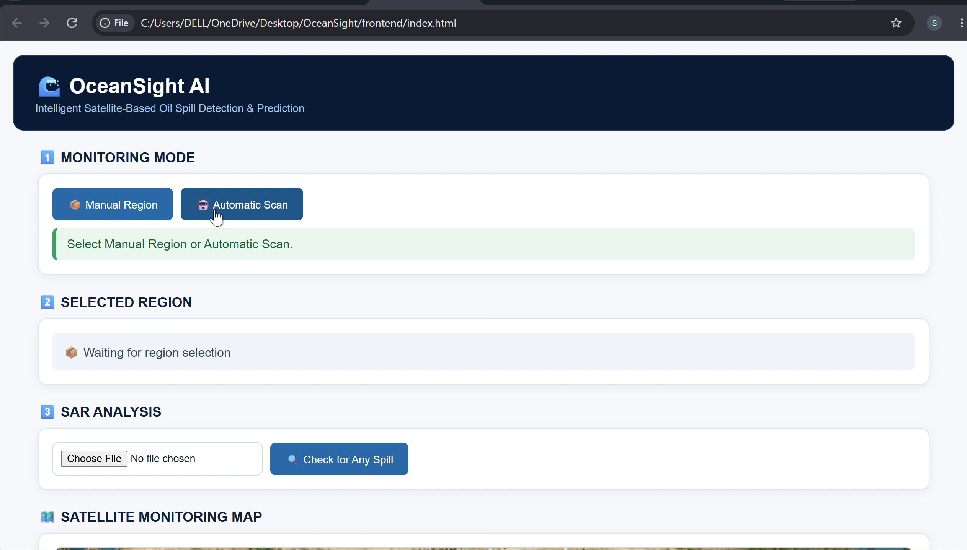

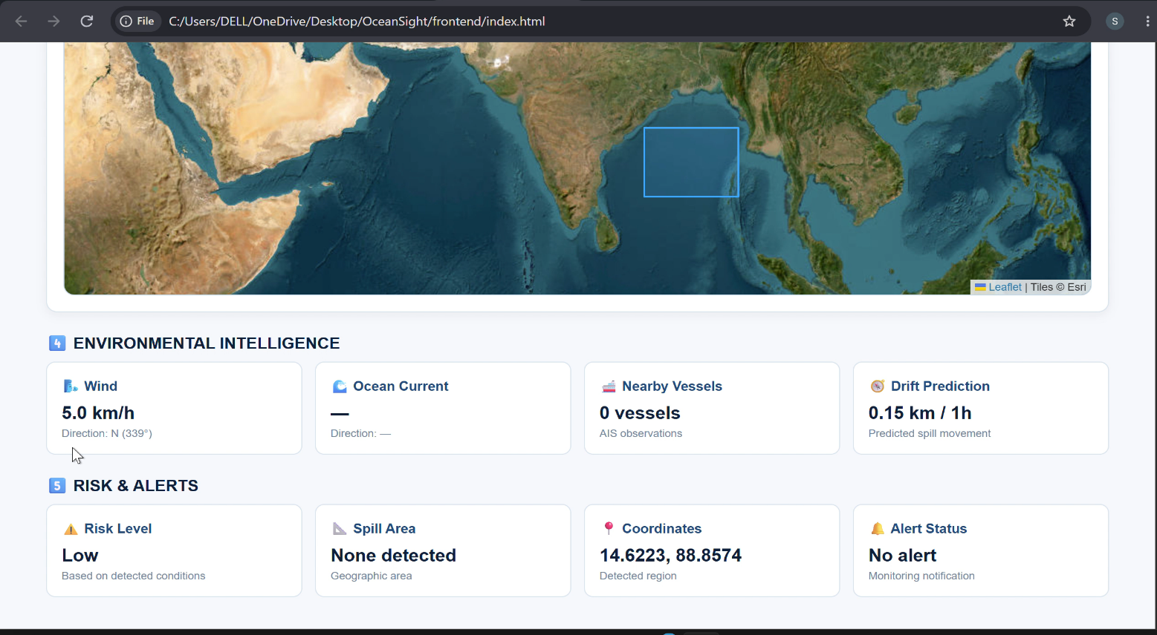

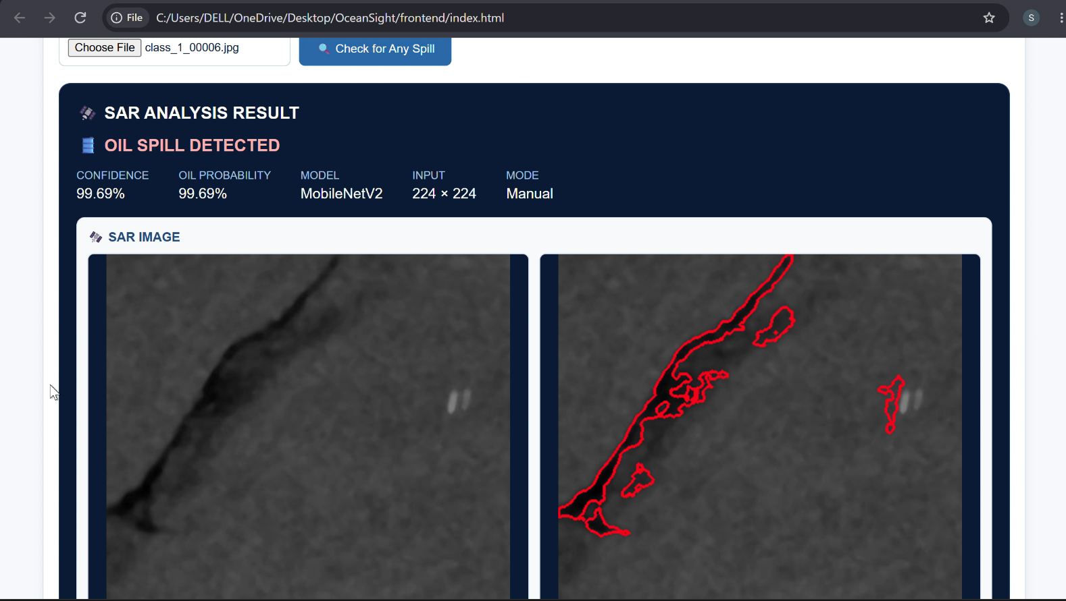

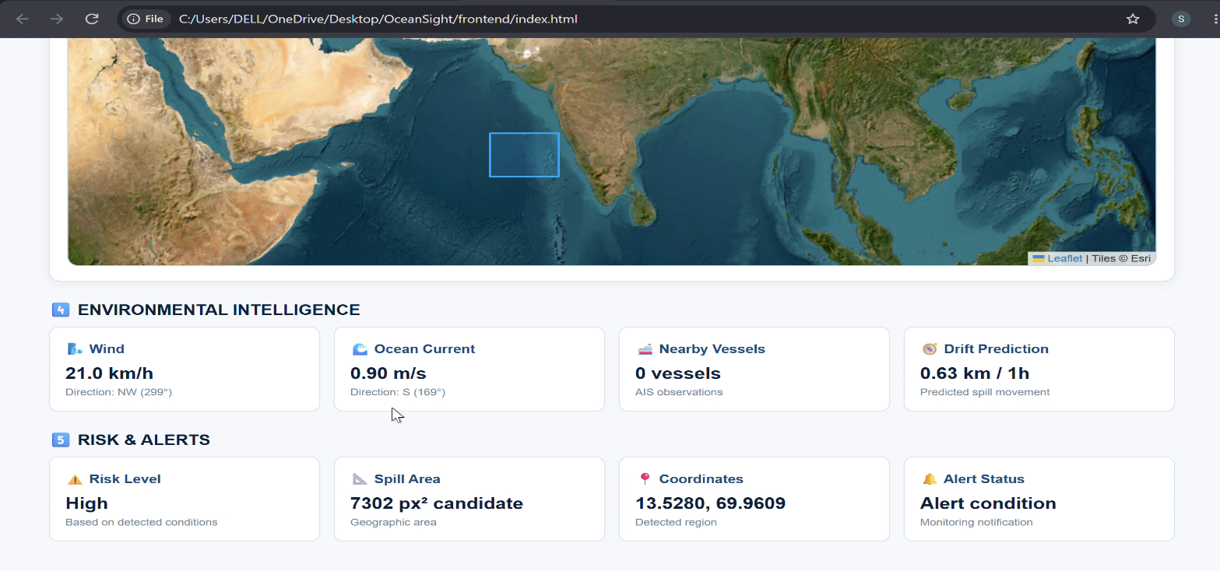

11.2 SAR Detection Results
SAR imagery was used to support marine surface observation and oil-spill analysis. The system processes the selected SAR image and identifies whether the input corresponds to a potential oil-spill condition using the trained classification model.
The detected region can subsequently be examined using image-processing techniques to identify an approximate candidate boundary. This provides additional spatial information for visualization and further analysis.

11.3 GIS-Based Results
The detected spill information can be represented geographically using GIS-based visualization. This allows the detected region to be considered together with surrounding geographic features and other available data layers.
Analysis | Output
Spill Detection | Oil Spill / No Oil Spill
Spatial Analysis | Candidate spill region
GIS Visualization | Geographic representation
Area Analysis | Approximate affected region

11.4 AIS and Environmental Analysis
AIS information can be used to examine vessels operating near a detected spill location. Vessel position, movement, heading, speed, and timestamps provide supporting information for identifying possible source correlations.
Environmental information such as wind and ocean-current conditions is used to understand the possible movement of the detected spill. These parameters provide additional context when interpreting the spatial position and potential movement of the spill.

11.5 Integrated Monitoring Results
The combination of the different analysis stages provides a broader view than oil-spill classification alone. A detected region can be examined spatially, compared with nearby vessel activity, and interpreted with environmental conditions.

Component | Result / Contribution
AI Classification | Identifies potential oil-spill condition
SAR Analysis | Supports marine surface observation
GIS | Provides spatial visualization
AIS | Supports possible vessel-source correlation
Environmental Data | Provides movement context
Drift Analysis | Estimates potential spill movement
Overall, the results demonstrate the feasibility of the proposed OceanSight AI workflow for combining AI-based detection with spatial, vessel, and environmental information to support marine oil-spill monitoring and assessment.

12. GLOSSARY
Term | Definition
AI | Artificial Intelligence; techniques that enable computer systems to perform tasks requiring intelligent decision-making.
AIS | Automatic Identification System; a maritime communication system used to provide vessel information such as position, speed, heading, and identity.
CNN | Convolutional Neural Network; a deep learning architecture commonly used for image analysis.
GIS | Geographic Information System; a system used to visualize, analyze, and manage geographically referenced information.
GNOME | General NOAA Operational Modeling Environment; a modelling framework used for analysing the movement of pollutants in water.
GPS | Global Positioning System; a satellite-based positioning system used to determine geographic location.
ML | Machine Learning; a branch of AI in which models learn patterns from data.
MobileNetV2 | A lightweight convolutional neural network architecture designed for efficient image classification.
SAR | Synthetic Aperture Radar; a radar-based remote-sensing technology capable of observing Earth's surface under varying lighting conditions.
Sentinel-1 | A European satellite mission providing radar-based Earth observation data, including SAR imagery.
Spatiotemporal | Relating to both geographic location and change over time.
U-Net | A neural network architecture commonly used for image segmentation.
Drift Analysis | Analysis used to estimate the potential movement of a substance under environmental conditions such as wind and ocean currents.
Oil Spill | The unintended release of petroleum or petroleum-based substances into a marine or aquatic environment.
Source Correlation | Analysis of available evidence to identify vessels or other factors that may be associated with a detected spill.

13. CONCLUSION
OceanSight AI presents an integrated approach for marine oil-spill detection, source correlation, and spatiotemporal risk assessment. The system combines AI-based image classification with SAR imagery, GIS, AIS, and environmental information to provide a broader monitoring workflow.
The MobileNetV2 model demonstrated the ability to classify labelled images into Oil Spill and No Oil Spill categories, achieving approximately 93% training accuracy. The system further extends the detected information through spatial visualization, vessel analysis, and environmental interpretation.
By bringing these components together, OceanSight AI can support the early identification and analysis of potential marine oil spills. The system is intended as a decision-support tool, with final environmental assessment requiring appropriate verification and additional evidence.

14. Future Enhancements
Several improvements can further increase the capability of OceanSight AI:
- Pixel-Level Segmentation: Replace image-level classification with segmentation models to identify the exact spill region.
- Multi-Temporal Monitoring: Compare satellite images acquired at different times to track spill evolution.
- Advanced Risk Assessment: Incorporate additional coastal, ecological, and environmental factors for more detailed risk estimation.
- Improved Drift Modelling: Use more advanced oceanographic models and higher-resolution environmental data.
- Automated AIS Correlation: Automatically analyse vessel trajectories and timestamps around detected spill locations.
- Larger and Diverse Datasets: Expand training data across different geographic regions, sea conditions, and spill types.
- Real-Time Alerts: Develop automated notifications for newly detected potential spills and high-risk regions.
- Cloud-Based Deployment: Enable continuous large-area monitoring using scalable cloud infrastructure.

15. REFERENCES

- Bianchi, F. M., Espeseth, M. M., & Borch, N. (2020). Large-scale detection and categorization of oil spills from SAR images with deep learning. Remote Sensing, 12(14), 2260. https://doi.org/10.3390/rs12142260
- Shaban, M., Salim, R., Abu Khalifeh, H., Khelifi, A., Shalaby, A., El-Mashad, S., Mahmoud, A., Ghazal, M., & El-Baz, A. (2021). A deep-learning framework for the detection of oil spills from SAR data. Sensors, 21(7), 2351. https://doi.org/10.3390/s21072351
- Hasimoto-Beltran, R., Canul-Ku, M., Díaz Méndez, G. M., Ocampo-Torres, F. J., & Esquivel-Trava, B. (2023). Ocean oil spill detection from SAR images based on multi-channel deep learning semantic segmentation. Marine Pollution Bulletin, 188, 114651. https://doi.org/10.1016/j.marpolbul.2023.114651
- Li, C., Kim, D.-J., Park, S., Kim, J., & Song, J. (2023). A self-evolving deep learning algorithm for automatic oil spill detection in Sentinel-1 SAR images. Remote Sensing of Environment, 299, 113872. https://doi.org/10.1016/j.rse.2023.113872
- Candido, C. G., & Principe, J. A. (2024). Dual-polarimetric decomposition of Sentinel-1 SAR image and machine learning model for oil spill detection: Case of Mindoro oil spill. The International Archives of the Photogrammetry, Remote Sensing and Spatial Information Sciences, XLVIII-4/W8-2023, 101–106. https://doi.org/10.5194/isprs-archives-XLVIII-4-W8-2023-101-2024
- Luo, D., Chen, P., Yang, J., Chen, X., Li, X., Zheng, G., Ren, L., & Zhao, Y. (2024). A new ship tracing technology from oil spills based on multi-source data. Marine Pollution Bulletin, 207, 116808. https://doi.org/10.1016/j.marpolbul.2024.116808
- Yang, Y.-J., Singha, S., & Goldman, R. (2024). A near real-time automated oil spill detection and early warning system using Sentinel-1 SAR imagery for the Southeastern Mediterranean Sea. International Journal of Remote Sensing, 45(6), 1997–2027. https://doi.org/10.1080/01431161.2024.2321468
- Prasad, S. J., Balakrishnan Nair, T. M., Rahaman, H., Shenoi, S. S. C., & Vijayalakshmi, T. (2018). An assessment on oil spill trajectory prediction: Case study on oil spill off Ennore Port. Journal of Earth System Science, 127(8), 111. https://doi.org/10.1007/s12040-018-1015-3
- European Space Agency. (n.d.). Sentinel-1: Earth observation satellite mission. European Space Agency.
- Copernicus Data Space Ecosystem. (n.d.). Sentinel-1 data and services. European Union / Copernicus Programme.
- National Oceanic and Atmospheric Administration. (n.d.). General NOAA Operational Modeling Environment (GNOME). NOAA.
- TensorFlow. (n.d.). MobileNetV2 documentation. Google / TensorFlow.
- OpenCV. (n.d.). OpenCV documentation. Open Source Computer Vision Library.

PO AND PSO ATTAINMENT TABLE
The below table explains how the SafeRide project aligns with the Program Outcomes (POs) and Program Specific Outcomes (PSOs) defined by the NBA for the Department of Electronics and Communication Engineering at Chennai Institute of Technology.

Attribute | Attained | Justification & Mapping to OceanSight AI
PO 1 | Yes | Applied engineering knowledge in machine learning, image processing, remote sensing, SAR imagery, GIS, and environmental data analysis for intelligent oil spill detection.
PO 2 | Yes | Analyzed limitations of conventional monitoring and manual SAR interpretation, identifying the need for automated detection, localization, and integrated environmental analysis.
PO 3 | Yes | Designed an integrated monitoring framework combining MobileNetV2, Sentinel-1 SAR data, GIS layers, AIS vessel information, environmental parameters.
PO 4 | Yes | Performed systematic experiments involving dataset preparation, training, validation, prediction analysis, model evaluation, and candidate-region/boundary analysis.
PO 5 | Yes | Utilized modern engineering tools such as Python, Google Colab, TensorFlow, Keras, OpenCV, NumPy, FastAPI, GIS tools, and Sentinel-1 data services.
PO 6 | Yes | Addressed a significant environmental and societal problem by developing an automated system for early detection and monitoring of marine oil pollution.
PO 7 | Yes | Supported sustainable engineering practices through satellite-based monitoring and AI-assisted analysis, reducing dependence on manual surveillance.
PO 8 | Yes | Followed responsible engineering practices by clearly documenting model performance, assumptions, limitations, uncertainties, and data constraints.
PO 9 | Yes | Supported effective teamwork through coordinated work in machine learning, SAR processing, GIS analysis, external data integration, system development, and documentation.
PO 10 | Yes | Presented technical information through system architecture, processing workflows, GIS visualizations, result tables, model analysis, and structured project documentation.
PO 11 | Yes | Demonstrated effective engineering resource management using lightweight MobileNetV2, Google Colab, open-source libraries, and publicly available satellite datasets.
PO 12 | Yes | Developed and applied new knowledge in deep learning, SAR remote sensing, GIS, AIS vessel analysis, environmental parameters, and drift analysis.
PSO 1 | Yes | Applied ECE-related technologies for processing satellite remote-sensing data, geospatial information, and AIS-based vessel information.
PSO 2 | Yes | Developed an innovative intelligent system integrating AI-based detection, SAR imagery, GIS, AIS, environmental data, and drift analysis for oil spill monitoring.

